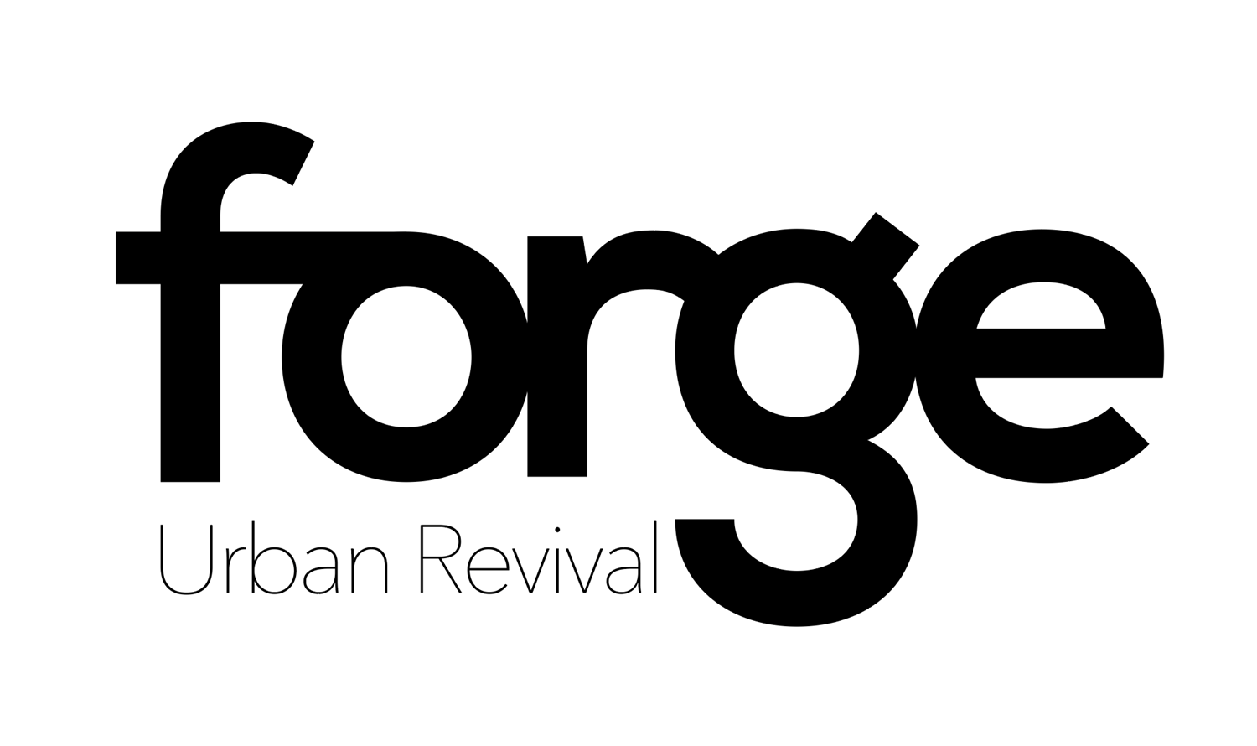

Artists, Designers and Crafters Terms and Conditions
Contents

Welcoming local Artists and Crafters to FORGE 2
Rent and Commission 2
Working with Artists and Crafters 2
Liability, Risk and Security 3
Why FORGE Urban Revival? 4
Confirmation 4

Welcoming local Artists and Crafters to FORGE

FORGE is committed as part of its social purpose to support the local community to succeed and benefit from their skills, interests and talents. To meet this aim we look for artists, crafts people and product designers who are just starting off in business, wanting to test the market and/or looking for affordable routes to sell on the high street.
To sell within the Telford FORGE we are looking for Shropshire based businesses that make, design or add value to goods. In some exceptions we will accept applicants from neighbouring counties who we could equally deem to be local to the Telford area.
We would first request images, detail along with costs of the product if we were then interested to include the item(s) in FORGE we would ask to see the products so we can ensure quality and range of products.
To learn more about the ethos, approach and current siting of FORGE Pop Up Shop then go to www.forgeurbanrevival.co.uk you can also follow us on TWITTER ForgeurbanR and/or Facebook https://www.facebook.com/Forge-Urban-Revival-1666651090254464/

Rent and Commission

Rent for Artists and Crafters for 2016 is £20.00 per four weeks (5.00 per week) this allows an artist or crafter to have space (shelf) approximately 152cm in length and 30cm deep.
In addition to rent we will charge 12% at the point of sale.
Rent payments are to be made in advance. A month’s notice period is required for an artist wishing to stop selling through FORGE
Large art works on agreement will be charged at 5.00 per month plus commission.
FORGE may also request that a product/range of items or individual cease trading through FORGE. We expect this to be in limited circumstances perhaps related to quality, not meeting customer need or other exceptional circumstances. Any such decisions would be discussed as early as possible with the artist, crafter or designer in order to rectify the situation.
When rent is not settled in advance then contact will be made with the artist/designer or crafter within two weeks asking for the rent to be settled and/or the goods to be taken from FORGE. Failure to do either will mean that after 6 months we will take ownership of the goods and any sales income gained from it in the 6 months period. Requests for collection of goods within the 6 months will require any outstanding rent and commission collected.
Sellers can pay in advance once every four weeks, perhaps using this time to come into FORGE refresh items, pay next rent and/or collect monies owed to you. We will create monthly statements of monies owed to you on sales (having taken out our commission) this will be available to be paid monthly to you. For those that would prefer we can arrange monthly transfers into sellers bank accounts.

Working with Artists and Crafters

We can offer a range of support within the rent at FORGE:
- You will not be offered a fix space in FORGE you goods will be circulated around the shop to ensure an attractive, designed and frequently changing shop environment that will look more like a cohesive retail space than a series of individually rented display cabinets. We will take this approach to both promote your wares but to also attract repeat visits to the shop. All items will be ticketed with a price from yourself and a code so we know when items of yours have been sold.
- We can offer you the chance and market the opportunity for people to come in and Meet the artist/crafter session. This would be marketed so that people could come along and meet the artist at a particular time/know they are in the shop. We would hope in this time within FORGE sellers would not just talk to visitors but also provide a few hours voluntary support to FORGE.
- We would have a biography of you as an artist producer within the shop with a link to more information where visitors can learn more about your work or see a wider range of products
- If you are interested in running workshops to teach and/or allow people to experience and learn some of your craft then where we can within our pop-up shops we would provide and encourage you to run workshops. We would provide the space, shared marketing and coffee at the workshop. We would recommend that attendees pay in the region of 10.00+materials to attend and those attendance monies are split 50% between FORGE and the facilitator. (materials to be provided by facilitator)
- We would take images of your work and publicise through our FORGE social media routes so that we encourage customers to visit FORGE and improve sales.
- For those that would benefit from it we are happy for you to attend at no cost our Junction Box meet-ups in either Telford or Shrewsbury where we hope you will learn how to further develop your product/idea.
- If you want to build your customer facing skills we would be happy to provide you with some volunteer customer sales training and mentoring within FORGE
- We would see much value in helping you progress your business/hobby so will be happy to keep you in the news loop of business support, free business events etc.

Liability, Risk and Security

We are not able to insure individuals work, items and products within FORGE, you place your products at your own risk and so it might be wise to take suitable insurance against theft, fire and damage etc. It is worth noting however that we will take as much care about security as we can, this will include when possible selecting sites that offer added security features; being careful where we site goods in their location to doors and exit areas; securing items to fixtures as well as we can and of course handling goods with as much care as possible. Whilst taking all these precautions we do not take full responsibility for loss or damage to items left at the shop.
Public liability: We recommend that all our suppliers take out public liability to manage/mitigate the risk of a product to a member of the public. It is not a precursor of selling through us but it may put you at personal financial risk if a product is later claimed to be dangerous in any form or posing a health risk to the public.
FORGE by nature is a pop-up shop and this will mean that every 3-4 months FORGE will move to another high street shop in Telford. This may add an additional risk in transit to delicate/vulnerable items and so in we recommend that artists/crafters and designers by default move or help us move items from one shop to another. If this is inconvenient then we ask you to provide us with express permission to move your items. You may decide that you do not wish your items to move to the next site in this case you would need to provide us with the necessary notice period. We would recommend however that artists do move to each site so as to maximise interest in revisiting new locations and in providing maximum exposure to local made Shropshire goods.
We would be very happy to advise and work with you on mitigating risk, seeking insurance and improving security. FORGE works best when we work together.

Why FORGE Urban Revival?

FORGE Urban Revival is a Pop-Up shop owned and managed by a Social Enterprise called Wave-length Social Marketing CIC more details can be found at www.wave-length.org.uk Wave-length is a not for profit social enterprise. The social aim of Wave-length overall is to improve services and employment opportunities to those who particularly face social challenges in life, this is achieved through not just supporting individuals but also working with organisations that have the ability and opportunity to remove social barriers.
Wave-length helps employers/service providers through its Wave-length Well which can be found on the Wave-length website and then through a programme called the Junction Box www.junctionbox.org.uk provides self-employment education and support to those seeking meaningful occupation in the community.
All profits of FORGE Urban Revival will be feedback into the social enterprise so as to improve lives in Shropshire and surrounding areas. We also offer works experience and training within FORGE to those unemployed and seeking to better their CV. This means that commissions and rent earned on your goods/products help others to succeed and develop their skills, hobbies and experience.
FORGE Urban Revival has only been made possible by the following: Telford and Wrekin Council offering us an amazing grant through Pride In Your High Street – FORGE would not exist without this; to all the volunteers at Junction Box and beyond who have worked on getting FORGE off the ground; to local large businesses and organisations who have donated to FORGE to making it such a fab environment and lastly but no less important TTC who without their belief in the concept of Wave-length we would not exist as an organisation. There are some amazing people in Shropshire and we hope that this trickles through to the success of your products when selling and working with us.

Confirmation and Contact

If you wish to join FORGE Urban Revival or have further questions please contact us on communications@forgeurbanrevival.co.uk and we will come back to you.
To confirm a space at the new and exciting FORGE opening in Wellington on the 16th April please complete the initial application form below and send back.
After submission we will come back to you with next steps, we will also be back with you at some stage to ask about the range of your goods and a profile, but in the first step is the form below. Look forward to meeting with you and seeing your products within FORGE.

Application Form for Forge Urban Revival

I would like to be considered for selling my goods through FORGE. I have read through the terms above and confirm the following:
Name
Business Name (if you have one)
Where are you based? Or live?
Please provide a description of your goods?
How do you ensure the quality/or safety of your goods (if applicable)
Do you have public liability insurance?
Please provide any social media links to your products i.e. website or social media links
Your preferred contact details
When would you be ready/available to bring your goods to FORGE and start selling?
How would you like to pay your 20.00 per 4 week rent? Cash in advance and/or bank transfer in advance?
Are you happy with FORGE moving your goods from site to site or would you want to do this yourself?
(please note if we move items, whilst we will take care of the goods it will be at your own risk)

Any information or questions you would like to ask us at FORGE?
I understand the conditions of selling at FORGE Urban Revival when joining them at the Pop-Up Shop
Name:

Date:

