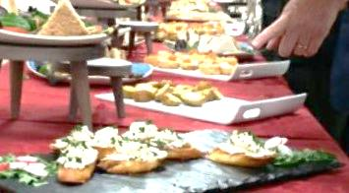
‘Forge’ your own buffet
Forge you own buffet when you book a room, party or occasion at The Wakes

To ‘Forge’ your own buffet first choose menu 1 or 2
Menu 1 £4.50 | Menu 2 £4.80
Sausage rolls  Vegetable spring rolls  Cocktail sausages  Pork pie wedges  Crudities and dip  Spicy potato wedges and dip  Onion Bhajis  Sandwich choices  (sandwich choices below)  Crisps | Sausage rolls  Bbq chicken drumsticks  Vegetable samosa  Breaded mushrooms and dip  Scotch egg wedges  Pork pie wedges  Honey and mustard sausages  Sandwich choices  (sandwich choices below)  Crisps

Our buffet can be served hot or cold !
If you want a fully bespoke buffet to meet your budget, cultural or social needs we would be happy to chat with you. Or if you are just planning a working lunch/crisps with colleagues then we have a single sandwich platter menu starting from £10.00 (per platter to serve 10 people). We also offer a breakfast buffet with a range of hot and cold options to suit your event/budget. Prices are currently not subject to VAT so the price you see is the price you pay
All our products are freshly prepared on site, we use only the best locally sourced food which and can be served hot or cold. We will layout your buffet using our unique stands and platters, we will also use table cloths on the display table so your buffet will look special and inviting. We provide all plates, cutlery, serviettes etc included in the price. we will clear all this away at the end of the buffet so you don’t have to worry. If you would like to have your own waitress perhaps to serve drinks, pass people food or meet and greet we can provide this at a cost of £15 per hour
Next step: Choose 4 from the following sandwich platter selection
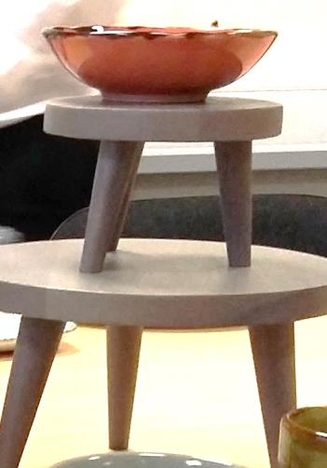
Ham salad
Coronation chicken
Egg mayonnaise and cress
Cheese and pickle
Chicken and sweetcorn mayonnaise
Ham & mustard or tomato
Blt and mayonnaise
Bacon and sliced egg with mayonnaise
Cheese and red onion
Sliced egg salad
Tuna and sweetcorn mayonnaise
Tuna and cucumber mayonnaise
Vegan cream cheese and chutney
Vegan cheese and pickle
Houmous, lettuce and chutney

Why not change to foccacia, soft rolls, ciabatta or sourdough bread for only 25p per person extra

Next step – Do you want to add anything else? More food choices, desserts or tea/coffee or are you happy to stop now?

Additional items: add any of the following platters for 30p per person (min 20 people)

Spicy chicken wings  Chicken and bacon vol au vents  Crudities with garlic dip  Indian savouries  Potato skins with cheese and red onion  Quiche slices  Nachos with spicy chilli dip  Scotch eggs  Vegetable samosas | Cheese and pineapple  Chips and mayonnaise dip  Spicy potatoes wedges with bbq dip  Breaded scampi  Selection of pickles and olives  Bruschetta topped with pate and cucumber  Chargrilled vegetable bruschetta  Devils on horseback  Baby falafel with tomato dip

Next step its ‘Sweet time’
Do you want add individual homemade cakes or large centre cakes?
With the exception of the Danish Pastry Selection all cakes are baked at Forge by our award winning cook.
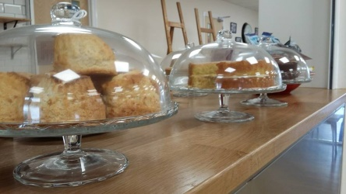
Chocolate fudge cake (10 people minimum) £1.95
Decorated fairy cakes £1.00
Shortbread cookies £1.00
Fresh fruit platter with chocolate dip £2.50
Chocolate eclairs £1.85
Fresh fruit pavlova £2.25
Danish pastry selection £1.00
Freshly made scone with jam and cream £1.75

Next step: Drinks do you want to purchase tea/coffee of prosecco for your guests or would you like our licenced bar /coffee counter open and they can purchase their own?
If you want to pay for tea/coffee then
Tea and coffee is only £1.00pp (served in a large flask min number 10)
Add a plate of assorted biscuits for only 25pp
Please note license bar being open is subject to confirmation with the council/forge.
……..
You can order your ‘Forged buffet’ choices via the Town Council when you book the room at The Wakes, or call in to see the Forge team at The Wakes to make sure we fully understand your need or ring Forge at 07715667975 or simply email communications@forgeurbanrevival.co.uk for more info
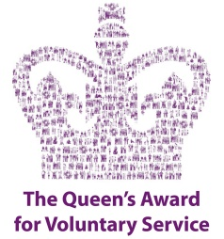
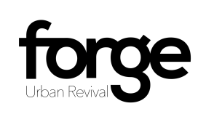
Forge Urban Revival is based at The Wakes, Oakengates TF2 6EP, we have a wonderful fresh food café open Mon-Friday and are happy to cater for day and evening buffets. We can cater for small buffets, business lunch and those big parties you have in mind as you book your function, meeting or party at The Wakes. Forge is a profit for purpose organisation meaning that all surplus profits we make go back into the community you live and work in, so spending money with us on a great menu means that you are helping to reduce social isolation and improve well-being and opportunity in the local area.
Forge has a 5 star food rating for its food production quality (highest badging) Forge is extremely proud of receiving the Queens Award for Voluntary Service to the community
Thank you for choosing Forge to provide your buffet

